[Lab no 01] [CSL-110 Computing Fundamentals]

[MS word fundamentals]

NAME= AHSAN SAJJAD

ENRO NO = 02-131212-049

Task # 1: Design following layout for input output storage devices.

**SOLUTION:**

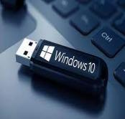

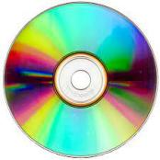

Can you think of any other storage devices?

Storage Devices are used to record (store) data.

STORAGE DEVICES

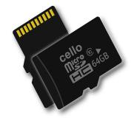

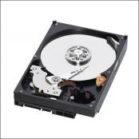

USB

MEMORY CARD

MEMORY CARD

CD/DVD..

Hard disk